# LAB 01: Introduction to Emulator 8086

**Objectives:**

Introduction to the emu 8086 assembler and its procedure of operation.

**Pre-Lab Task**

There are over a hundred instructions in the instruction set for the 8086 CPU. But in today’s lab we will discuss some of the most useful instructions. These are:

|  |  |  |
| --- | --- | --- |
| **Instructions** | **Description** | **Example** |
| **MOV** | Transfer data between registers, between register and a memory location, **MOV**E a number directly into register or memory location. | **MOV AX, Word1**  **MOV AX, BX**  **MOV AH,’**A**’** |
| **XCHG** | Exchanges the contents of two registers, or a register and a memory location. | **XCHG AH, BL**  **XCHG AX, Word1** |
| **ADD** | **ADD**s contents of two registers, a register and a memory location, a number to a register or memory location. | **ADD Word1, AX**  **ADD BL,5** |
| **SUB** | **SUB**TRACTS contents of two registers, a register and a memory location, a number to a register or memory location. | **SUB AX, DX** |
| **INC** | **ADD**s 1 to the contents of a register or memory location | **INC Word1** |
| **DEC** | **Sub**tracts 1 from a register or a memory location. | **DEC Byte1** |
| **NEG** | Replaces the contents of destination by its two’s complement. | **NEG BX** |

**LAB WORK:  
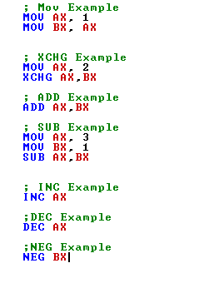**

**In-Lab Task:**

**8086 EMULATORS**

**Emu 8086 startup**





Start emulation by clicking the “emulate” button on the toolbar. A new emulator window will appear.

******Post lab Assignment**

Practice all commands done with debugger in emu8086.

**Critical Analysis /Conclusion**

|  |
| --- |
|  |

|  |  |  |  |
| --- | --- | --- | --- |
| **Performance (15Marks)** | | **Viva**  **(5 Marks)** | **Total/20** |
| **Pre-Lab Exercise** | **/3** |  |  |
| **Performance** | **/4** |  |  |
| **Results** | **/3** |
| **Critical Analysis** | **/2** |
| **Post Lab Exercise** | **/3** |
| **Comments** | | | |